CS6650 HW1 Report

Name: Ziqi Wen

Github: https://github.com/JasonWen1/HW1-NEU6650

ClientDesgin:

I use AlbumMetaData class to hold the data we need to POST, I use methods sendPostRequest to handle post, and sendgetRequest to handle get.

For save to csv, I use opencsv as tools to help me write the data from list to csv.

For plotting, I use python matplotlib.pyplot to draw the throughput picture easily.

How to run the client:

Run main method need 4 parameters: <threadGroupSize> <numThreadGroups> <delay> <IPAddr>

So just like “10 10 2 [http://localhost:8080/xxxx/albums”](http://localhost:8080/xxxx/albums\”)

For go server I use http://[IP_ADDRESS]/IGORTON/AlbumStore/1.0.0/albums

For java server I use http://[IP_ADDRESS]/[war_file]/albums

Becasue basic ec-2 is very slow, so I choosed a stronger server. But the comparation

between Java and Go server is same.

(I have begged extension from professor, so please do not deduct my late score, thank you so much!!!!! I have put a lot of effort for this course)

**Result of Client1**:

|  |  |  |
| --- | --- | --- |
|  | Go server throughput | Java server throughput |
| threadgroupSize = 10  numThreadGroups = 10  delay = 2 | 9975.56 | 9974.37 |
| threadgroupSize = 10  numThreadGroups = 20  delay = 2 | 9980.04 | 9978.2 |
| threadgroupSize = 10  numThreadGroups = 30  delay = 2 | 9979.54 | 9979.21 |

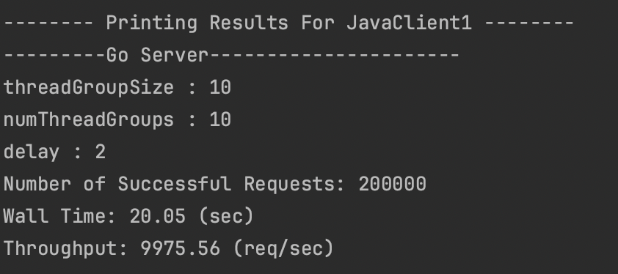

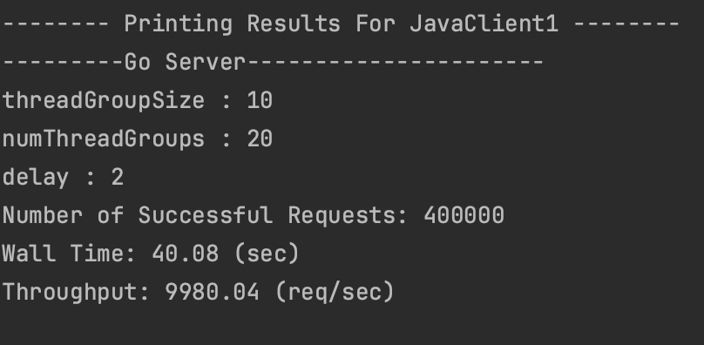

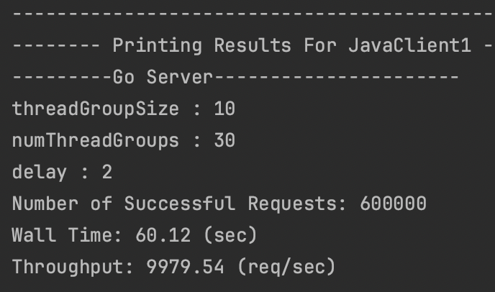

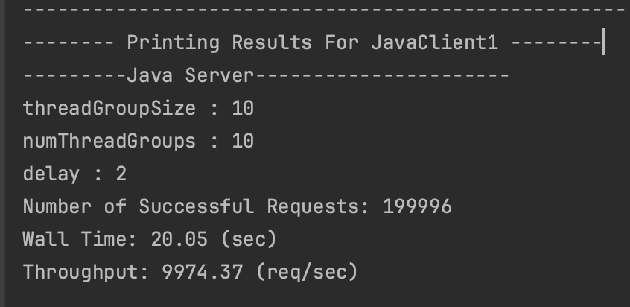

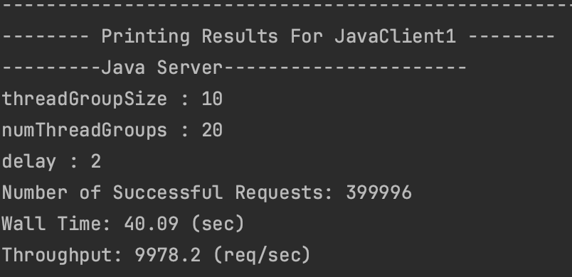

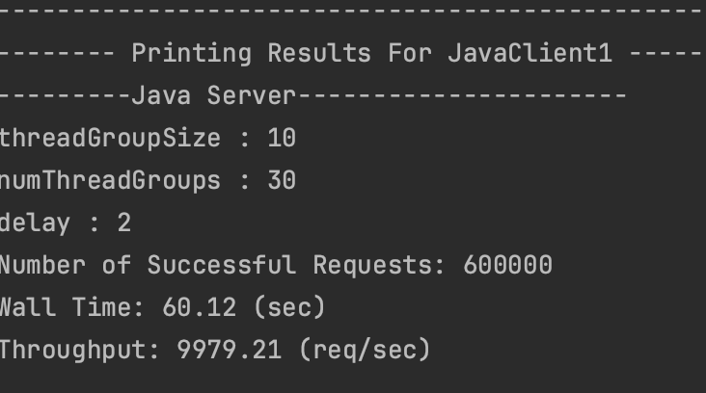

Client1 Go vs Java throughput

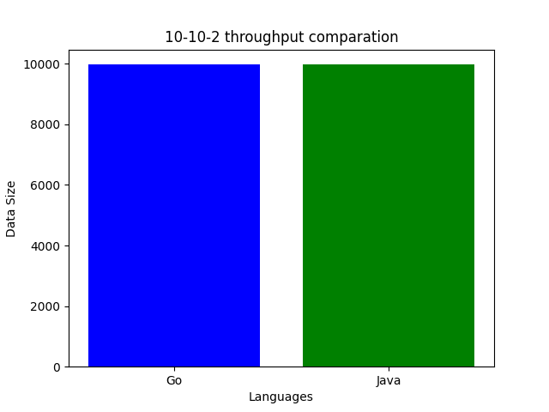

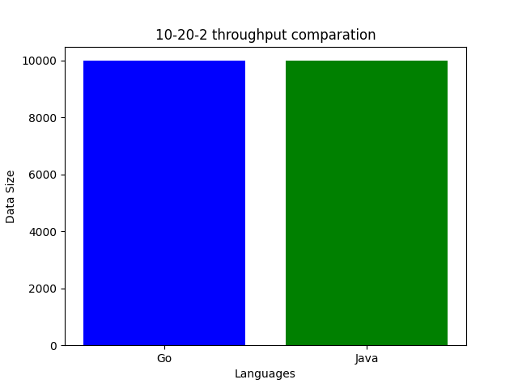

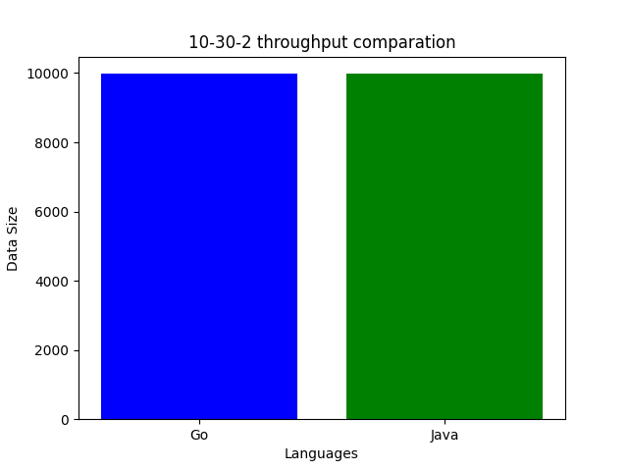

For client1, go and java throughput is nearly same, go is slightly faster than java.

**Result of Client2**:

|  |  |  |
| --- | --- | --- |
|  | Go server throughput | Java server throughput |
| threadgroupSize = 10  numThreadGroups = 10  delay = 2 | 9973.57 | 9976.8 |
| threadgroupSize = 10  numThreadGroups = 20  delay = 2 | 9979.29 | 9976.8 |
| threadgroupSize = 10  numThreadGroups = 30  delay = 2 | 9856.26 | 9867.17 |

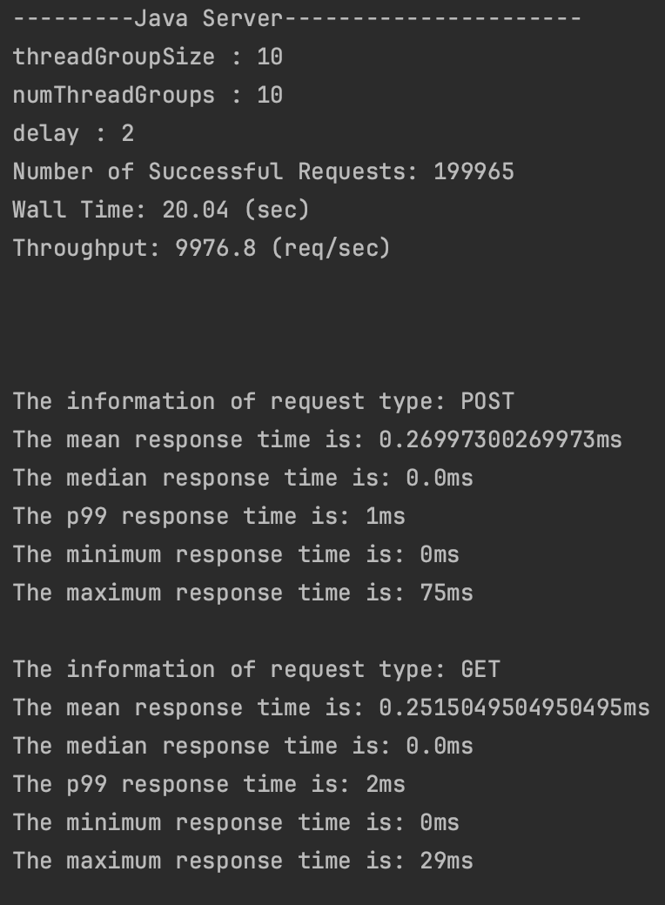

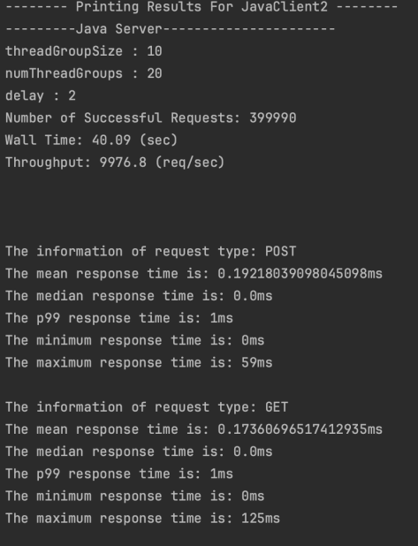

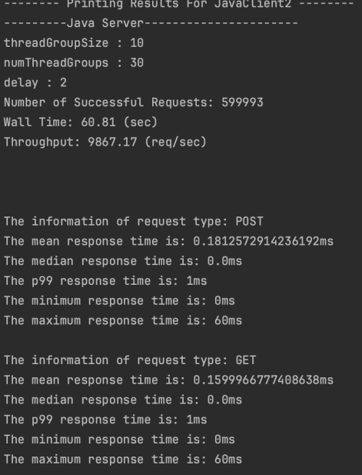

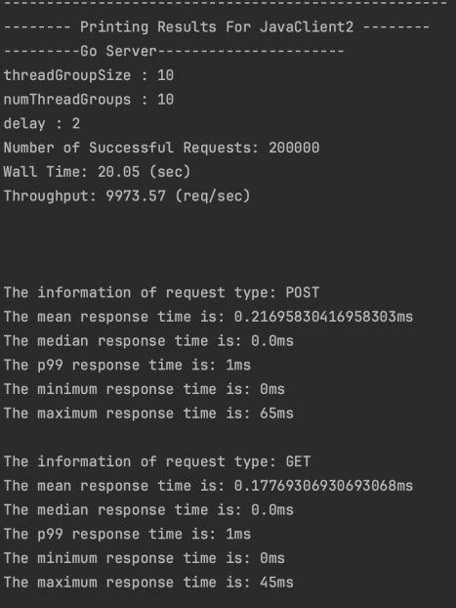

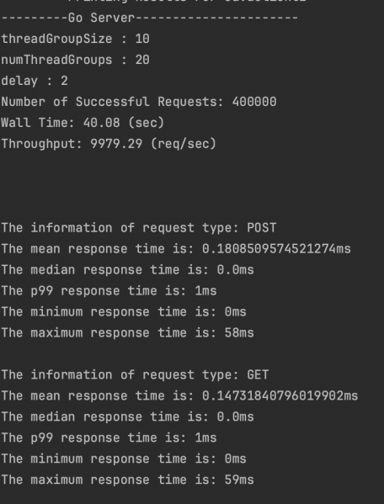

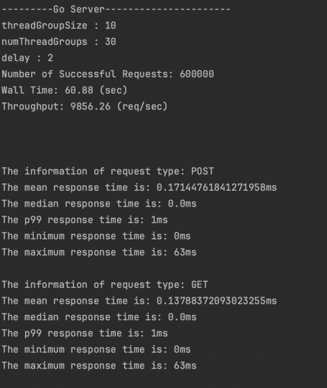

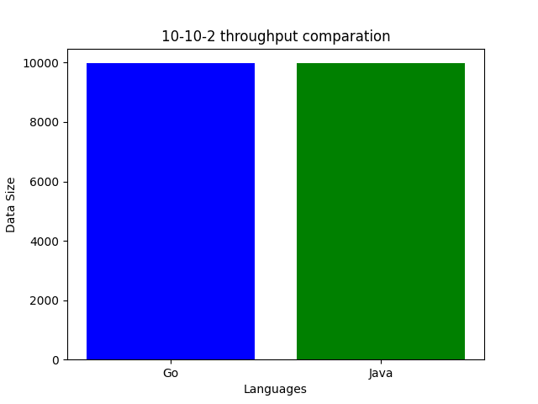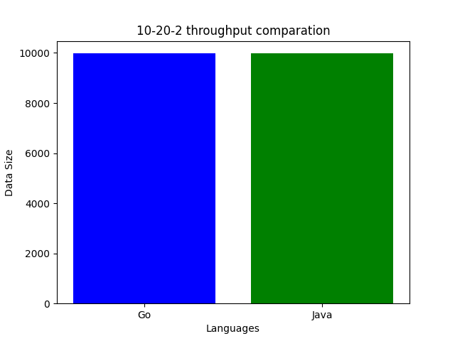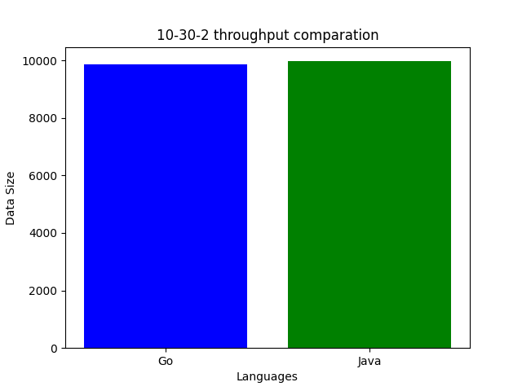

Client2, Go and Java still perform nearly same. We found when groups go large in client2, go and java become slower.

Go-10-30-2 throughput graph:

